**Class and Object Variable Process - Getter and Setter**

1.. Write a program to generate the getter and setter method for the variables defined in the class

class **Test**:

def **get_a**(*self*):

return *self*.__a

def **get_b**(*self*):

return *self*.__b

def **set_a**(*self*, value):

*self*.__a = value

def **set_b**(*self*, value):

*self*.__b = value

def **del_a**(*self*):

del *self*.__a

def **del_b**(*self*):

del *self*.__b

a=10

b=12

pass

ob=Test()

2. Create a variable for the object created for the class and display its content.

class Test:

def **get_a**(*self*):

return *self*.__a

def **get_b**(*self*):

return *self*.__b

def **set_a**(*self*, value):

*self*.__a = value

def **set_b**(*self*, value):

*self*.__b = value

def **display0**(*self*):

print(*"a="*,*self*.__a,*"b="*,*self*.__b)

ob=Test()

ob.set_a(10)

ob.set_b(12)

ob.display0()

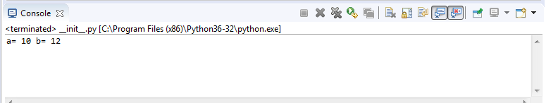

3. Delete the object created for the class.

class **Test**:

def **get_a**(*self*):

return *self*.__a

def **get_b**(*self*):

return *self*.__b

def **set_a**(*self*, value):

*self*.__a = value

def **set_b**(*self*, value):

*self*.__b = value

def **display1**(*self*):

print(*"a="*,*self*.__a,*"b="*,*self*.__b)

def **del_a**(*self*):

del *self*.__a

def **del_b**(*self*):

del *self*.__b

def **display**(*self*):

print(*"a="*,*self*.__a,*"b="*,*self*.__b)

ob=Test()

ob.set_a(10)

ob.set_b(12)

ob.display1()

del ob

print(ob)

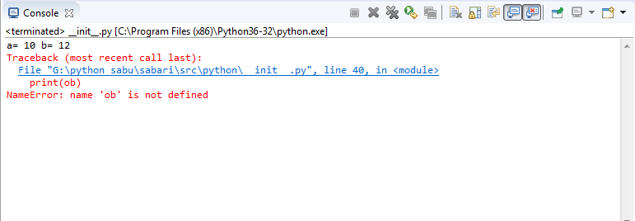

4. Delete the particular variable created for the object

class **Test**:

def **get_a**(*self*):

return *self*.__a

def **get_b**(*self*):

return *self*.__b

def **set_a**(*self*, value):

*self*.__a = value

def **set_b**(*self*, value):

*self*.__b = value

def **display1**(*self*):

print(*"a="*,*self*.__a,*"b="*,*self*.__b,*"Extra-C="*,*self*.c)

def **del_a**(*self*):

del *self*.__a

def **del_b**(*self*):

del *self*.__b

def **display**(*self*):

print(*"a="*,*self*.__a,*"b="*,*self*.__b)

ob=Test()

ob.set_a(10)

ob.set_b(12)

ob.c=29

ob.display1()

del c

ob.display()

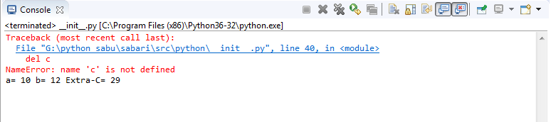

5. Write a program to generate the getter,setter and delete method for the variables defined in the class

**class Test:**

**def get_a(*self*):**

**return *self*.__a**

**def get_b(*self*):**

**return *self*.__b**

**def set_a(*self*, value):**

***self*.__a = value**

**def set_b(*self*, value):**

***self*.__b = value**

**def display1(*self*):**

**print(*"a="*,*self*.__a,*"b="*,*self*.__b)**

**def del_a(*self*):**

**del *self*.__a**

**def del_b(*self*):**

**del *self*.__b**

**def display(*self*):**

**print(*"a="*,*self*.__a,*"b="*,*self*.__b)**

**ob=Test()**

**ob.set_a(10)**

**ob.set_b(12)**

**ob.display()**

**ob.del_b()**

**ob.display()**

